“Oh no! My joey has herpes”
Dr “Rosemary Austen & Professor Steve Garlick
Oh no! My joey has Herpes: The occurrence and successful treatment of a Herpesvirus infection in Eastern Grey Kangaroos (1)
Dr Rosemary Austen BSc, MBBS, PhD Professor Steve Garlick MCom, PhD Possumwood Wildlife Inc www.possumwood.com.au

1. Introduction
Herpesviruses in humans cause diseases such as cold sores, genital herpes, chicken pox, shingles and glandular fever. A number of these infections are typified by skin ulceration. In Macropods five herpesvirus species have been identified, viz three alphaherpesvirueses and two gammaherpesviruses. Herpesviruses have been identified in a number of macropod species eg Eastern Grey (EG), Western Grey and Red kangaroos, wallabies, quokkas, pademelons and bettongs (Herpesviruses and Macropods. Fact Sheet).
Clinical signs of these herpesvirus infections include the following: discharge from the nose and eyes, sneezing, fever, decreased appetite, conjunctivitis, keratitis, anogenital ulcers, mouth ulcers, respiratory signs, swelling of the upper lip and death (Ladds). The American Association of Zoo Veterinarians Infectious Disease Committee Manual 2013 described the alphaherpesviruses as causing fatal systemic infections for which there was no known treatment.

2. The Occurrence and Successful Treatment of a Herpesvirus Infection in Eastern Grey Kangaroos – The Possumwood Experience
Symptoms of an illness now known to be due to a herpesvirus were first observed at Possumwood Wildlife Recovery Centre about ten years ago. A released 15 kg EG called Toby returned home with sneezing, vigorously rubbing his nose with his front paws and watering of the eyes. Several other released EG developed the same symptoms. All recovered without intervention. Outbreaks of the same symptoms as well as fever and lethargy were seen in EG at the Recovery Centre over the next few years. The EG were all over 5kg. All recovered without intervention. Pebbles, Maggie, Elise and Poppy have been released for about eight years, return to the cottage at the Recovery Centre daily and have not been observed to have had a reoccurrence of symptoms.
The first fatalities due to this illness occurred in 2011 when our small joeys (all less than 3 kg) were taken from the house to be cared for at the cottage in the Recovery Centre while Steve was overseas. These joeys would not have been exposed to the herpesvirus previously and did not have the usual protection of the antibodies in their mother’s milk. The Recovery Centre receives orphaned, sick or injured macropods regularly and a new arrival brought the illness into the Recovery Centre. All our small joeys developed the usual symptoms of runny nose, sneezing and watering of the eyes but the disease progressed to lethargy, respiratory difficulty, anorexia and death. The nasal passages of these joeys were swollen and became blocked by thick secretions which prevented them from breathing through their nose. Some joeys developed an expiratory wheeze. A veterinarian was consulted but he had not observed this illness before and was unable to help these animals despite IV antibiotics and fluids.

(1) Not yet refereed
It was noted that several of the joeys developed cloacal, nasal or corneal ulcers. Only three of the fifteen joeys survived. The loss of so many of our little joeys, some who had come in at 500-600 g, was devastating. Post mortem showed bilateral lung consolidation and gastrointestinal tract ulceration.
A number of medications were used to treat the symptoms of this illness viz Paracetamol for fever, Bromhexine, a mucolytic, to decrease the viscosity of nasal secretions and aid breathing, Mometasone nasal spray to reduce nasal swelling, Oxymetazoline to reduce nasal discharge, FESS nasal saline spray to clear nasal passages, Chloromycetin eye ointment for corneal ulcers, Ilium Neocort for cloacal ulcers, nebulized Salbutamol for wheezing, Nutrigel as a nutritional supplement, Sucralfate for gastrointestinal tract ulceration and Betamox IM or IV antibiotic to treat secondary bacterial infection.
The disease became known locally as ‘The Kangaroo Flu’. We were careful in future not to allow our small joeys to be exposed to animals exhibiting symptoms of this illness. When an animal was showing signs of the disease at the cottage it was essential that we showered and changed our clothes before re-entering the house after working at the Recovery Centre.
We did however have another outbreak in the small joeys at the house when a joey named Muffie was visiting the Recovery Centre daily for exercise and interaction as she was older than the other joeys at the house. She began to sneeze and was removed from the house but had already transferred the virus to the small joeys. The incubation period appeared to be around seven days. A little joey called Sophie developed signs of the disease and despite supportive treatment died. At this point we decided to trial a medication used for the treatment of herpesvirus infections in humans. We had observed the prevalence of cloacal, nasal and corneal ulcers in affected joeys and because of the propensity for the human herpesviruses to cause similar lesions we considered that what we were seeing might be a macropod herpesvirus infection in our joeys.
As soon as a joey was noted to be sneezing or appeared unwell we commenced them on Valaciclovir. This medication prevents viral replication and so it is important to commence it early in the illness as soon as signs of the disease are observed. Each Valaciclovir tablet is 500mg. The human dose is 1g of Valaciclovir (ie 2 tablets) three times daily for one week. We used the following dose rate for joeys. Crush one tablet finely and suspend in 15ml of cooled boiled water. Use at a rate of 0.5ml/ kg of the shaken suspension three times a day for seven days. This can be given before or with formula in a syringe to make it more palatable. Keep unused medication in the fridge for use the same day.

Sophie was the last joey who has died of this illness at Possumwood. Her friends Spencer and Darby stopped sneezing in about 3 days and the disease did not progress. During a later out break at the Recovery Centre Spencer and Darby did not develop signs of the herpes infection. Because of the Valaciclovir their symptoms were very mild but they still appeared to have developed immunity.
At the next outbreak of the virus I took a nasal swab from a joey called Heidi and requested a herpesvirus PCR to be done. This test confirmed that Heidi had a herpes infection. As soon as the swab was taken she was commenced on Valaciclovir and recovered uneventfully. On this occasion we decided to trial Valaciclovir as a preventive. The other joeys were given a ‘preventive’ dose of Valaciclovir (0.5ml/ kg of the previously described suspension once daily) and did not develop signs of the disease. These joeys, however, also appeared immune when later exposed to this virus as they did not develop any signs of the disease.
Figure 1. Pathology report: Herpesvirus PCR
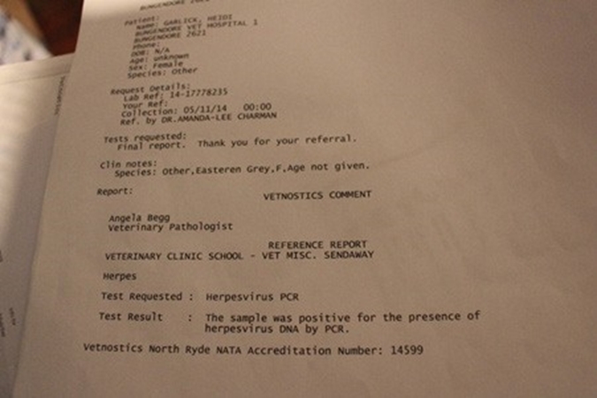
It is considered that macropod herpesviruses are not cleared from the body and can be reactivated due to stress such as is the case with shingles in humans (reactivation of the chicken pox virus due to waning immunity). Thirty EG who would have been previously exposed to the herpesvirus at Possumwood Wildlife Recovery Centre were recently translocated for release and despite this significant stress none developed signs of the herpesvirus infection.
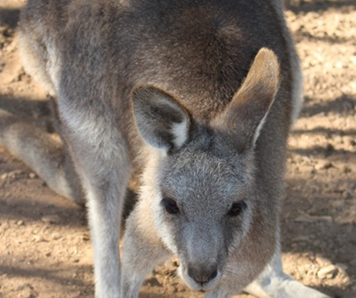
Figure 2. Heidi, 12 months after Valociclovir treatment and recovery from Herpesvirus
Valaciclovir has now been used successfully by a number of other macropod carers who have had joeys who have developed signs of a herpesvirus infection.

3. Summary
A viral infection which is fatal in small EG joeys was shown by herpesvirus PCR to be due to a herpesvirus. This herpesvirus infection has been successfully treated and prevented with Valaciclovir. Viral infections are an important cause of mortality in wildlife. It is only when human activity causes a native animal to become classified as an endangered species or there is a possibility of transfer to domestic animals that government agencies or scientists show interest in finding a treatment for wildlife infections. The loss of little joeys appears to be important only to their carer (the ACT Government orders the beheading of hundreds of little joeys every year). The knowledge that wildlife carers accumulate about the care and treatment of native animals such as EG kangaroos is very important for their future. The Koala and Tasmanian Devil, like the Kangaroo, were once considered abundant. The species considered abundant today is tomorrow’s endangered species.

4. References
Ladds, P. 2009. Pathology of Australian Native Wildlife. Collingwood: CSIRO Publishing.
Australian Wildlife Health Network. 2013. Herpesviruses and Macropods Fact Sheet. http:// wildlifehealthaustralia.net.au/Portals/0/Documents/FactSheets/Herpesviruses%20(Macropods)%20 12%20Feb%202013%20(1.1).pdf Accessed 11/ 7/2016.
American Association of Zoo Veterinarians. 2013. Infectious Disease Committee Manual. http://c.ymcdn.com/sites/www.aazv.org/resource/resmgr/IDM/IDM_Macropod_Herpesvirus_201.pdf Accessed 11/7/ 2016.
www.possumwood.com.au

